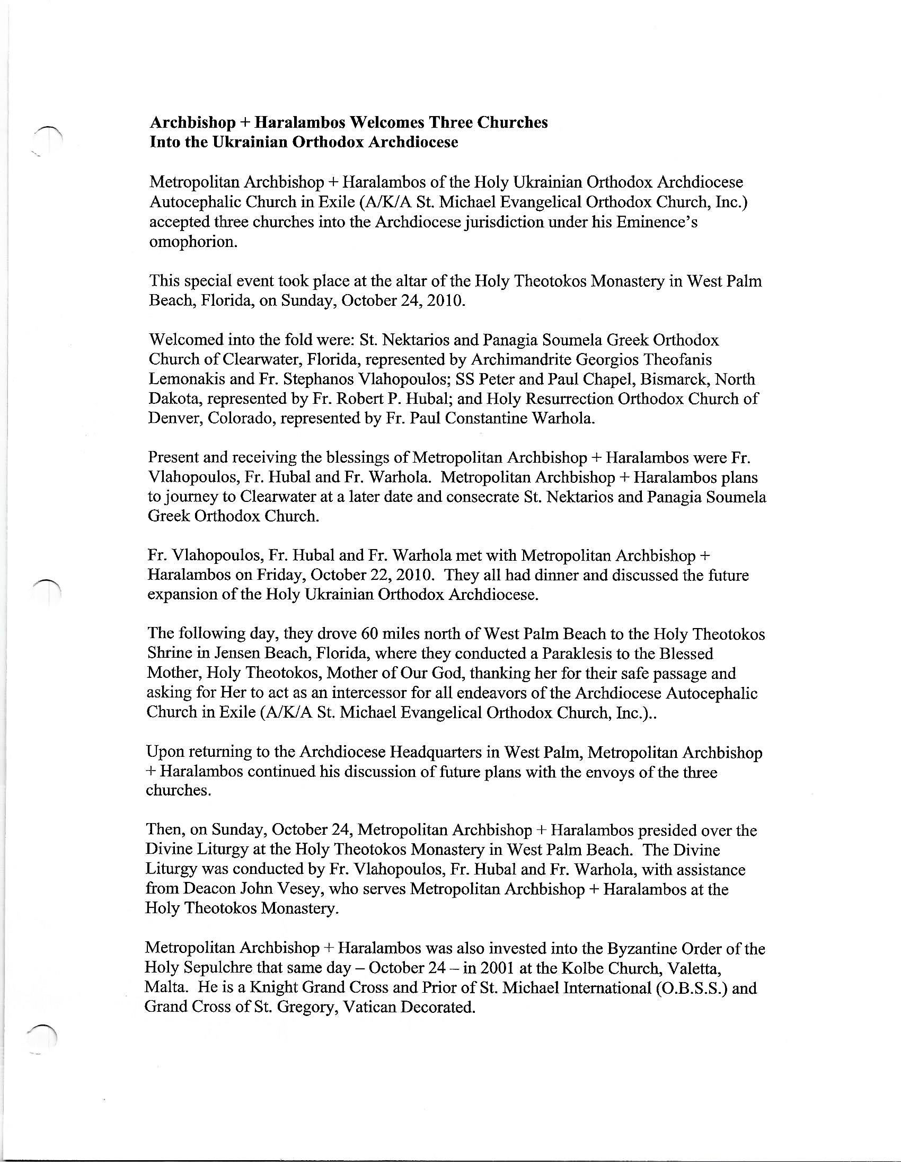
Former Ecclesiastical Jurisdiction History and Members (1) O.B.S.S. IS NOW O.S.S.

